TRIBHUVAN UNIVERSITY
INSTITUTE OF ENGINEERING
PURWANCHAL CAMPUS
DHARAN



ARTIFICIAL INTELLIGENCE

Lab Report IV

Submitted by:  Gokarna Baskota  PUR075BEI013 | Submitted To:  Department of Electronics and Computer  Engineering

Lab 4: Problem Solving by Searching: A* Search
Informed Search: Informed Search algorithms have information on the goal state which helps in more efficient searching. This information is obtained by a function that estimates how close a state is to the goal state. In this lab, we are going to implement A* search.
A* search is the most commonly known form of best-first search. It uses heuristic function h(n), and cost to reach the node n from the start state g(n). A* search algorithm finds the shortest path through the search space using the heuristic function
f(n) = g(n) + h(n).

This search algorithm expands less search tree and provides optimal result faster.
Algorithm
- Declare the visited list
- Declare the unvisited list
- For each node in graph:
– Add the node to the unvisited list with a g-score of infinity, an f-score of infinity and previous node of null.
- Set the start node's g-score to 0 in the unvisited list
- Set the start node's f-score to its h-score in the unvisited list
- Set finished to False
- While finished is False:
  - Set current node to the node in the unvisited list with the lowest f-score
  - If the current node is the target node
    - Set finished to True
    - Copy the values for the current node from the unvisited list to the visited list
  - Else
    - For each neighbor of current node:
      - If neighbor is not in the visited list
        - Calculate new g-score = weight of edge + g-score of current node
        - If new g-score is less than neighbor's g-score in unvisited list
          - Update the neighbor's g-score with the new g-score
          - Update the neighbor's f-score to new g-score + h_score
          - Update the neighbor's previous node to the current node
    - Copy the values for the current node from the unvisited list to the visited list
    - Remove the current node from the unvisited list

8. Return the visited list

We will use the A* algorithm to find the best path from Biratnagar to Damak in the
following map.

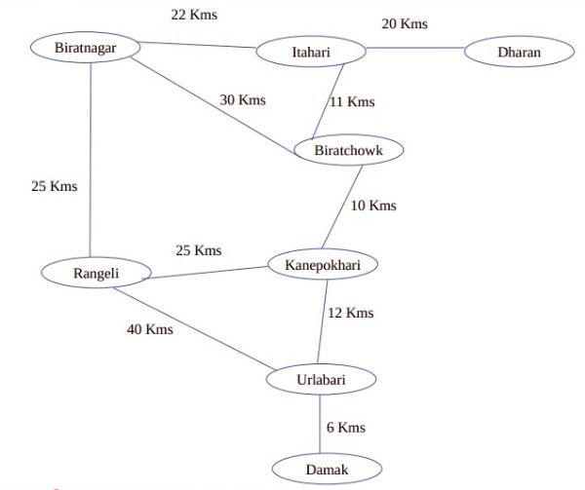
The straight line distance from each of the city to Damak is shown below:
Heuristic function h(n)
Biratnagar | 46 Kms
Itahari | 39 Kms
Dharan | 41 Kms
Rangeli | 28 Kms
Biratchowk | 29 Kms
Kanepokhari | 17 Kms
Urlabari | 6 Kms
Damak | 0 Kms

Program:

import numpy as np

g_index = 0
f_index = 1
prev = 2

def get_minimun(unvisited):
fval = np.inf
place = ""

for city in unvisited.keys():
if unvisited[city][1] < fval:
fval = unvisited[city][1]
place = city
return place

def Astar(graph, start, goal):
visited = {}
unvisited = {}
done = False

for place in graph.keys():
# g-score, f-score, previous
unvisited[place] = [np.inf, np.inf, ""]

unvisited[start] = [0, h[start], ""]

while not done:
if False:
done = True
else:
current_node = get_minimun(unvisited)
if current_node == goal:
done = True
visited[current_node] = unvisited[current_node]
else:
for neighbor in graph[current_node]:
if neighbor not in visited:
g_score = unvisited[current_node][g_index] + graph[current_node][neighbor]

if g_score < unvisited[neighbor][g_index]:
unvisited[neighbor][g_index] = g_score
unvisited[neighbor][f_index] = g_score + h[neighbor]
unvisited[neighbor][prev] = current_node

visited[current_node] = unvisited[current_node]
del unvisited[current_node]

return visited

graph = {
"Biratnagar": {"Itahari":22, "Biratchowk":30, "Rangeli":25},
"Itahari": {"Dharan":20, "Biratchowk":11, "Biratnagar":22},
"Dharan": {"Itahari":20},
"Rangeli": {"Kanepokhari":25, "Urlabari":40, "Biratnagar":25},
"Biratchowk" : {"Kanepokhari":10, "Itahari":11, "Biratnagar":30},
"Kanepokhari": {"Urlabari":12, "Rangeli":25, "Biratchowk":10},
"Urlabari": {"Damak":6, "Kanepokhari":12, "Rangeli":40},
"Damak": {"Urlabari":6}
}
# heuristic function h(n)
h = {
"Biratnagar": 46,
"Itahari": 39,
"Dharan": 41,
"Rangeli": 28,
"Biratchowk" : 29,
"Kanepokhari": 17,
"Urlabari": 6,
"Damak": 0
}

def make_map(dict, goal):
path = goal
temp = goal
while dict[temp][prev] != "":
path = dict[temp][prev] + "-->" + path
temp = dict[temp][prev]

return path

if __name__ == "__main__":

start = "Biratnagar"
goal = "Damak"

visit_node = Astar(graph, start, goal)

print(make_map(visit_node, goal))

Output:

